Administration Office

APPLICATION APPROVAL TO UTILIZE AN EXISTING APPROACH
PERMIT No.
THE APPLICATION BY NAME of APPLICANT FOR AN EXISTING APPROACH APPROVAL LOCATED AT W4M IS HEREBY APPROVED.

Therefore, permission is hereby granted to NAME to utilize an existing approach in accordance with the plan and specifications attached and any amendments noted thereto and subject to the terms and conditions as covered by the Municipal District of Taber.

- Approach must be graveled with ¾” or 1” gravel 10 meters from road shoulder. Progressive gravelling may be required at the discretion of the MD of Taber.

- Maintenance of any Texas gates and/or other fencing or access points is required.

- The Applicant shall indemnify and hold harmless the Municipal District of Taber, its employees and agents from any and all claims, demands, actions and costs whatsoever that may arise, directly or indirectly from the operation.

- If the construction intended under this permit has not been carried out within one year of the date of issuance, this permit lapses and the applicant must reapply for a new permit if they wish to proceed.

- It is the responsibility of NAME to contact Alberta One-Call and check for the presence of any underground facilities running within the road allowance.

Issuance of this permit does not excuse violation of any regulation, bylaw or act which may affect the proposed project. The term of the agreement is for one year and expires on April 29, 2020.
SPECIAL CONDITIONS:
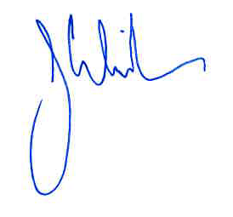
__
DATE MUNICIPAL DISTRICT OF TABER

